-/Creating freestyle project using Jenkins and Maven

Environmental Variables:
- System Variables:
  - Add new variable:
    - Variable: MAVEN_HOME
    - Value: path of maven
  - Go to edit path:
    - Add new path - %MAVEN_HOME%\bin
- User Variables:
    - Add new path - %MAVEN_HOME%\bin

Step 1: run the command-
mvn archetype:generate -DgroupId=com.example -DartifactId=hello-world -DarchetypeArtifactId=maven-archetype-quickstart -DinteractiveMode=false
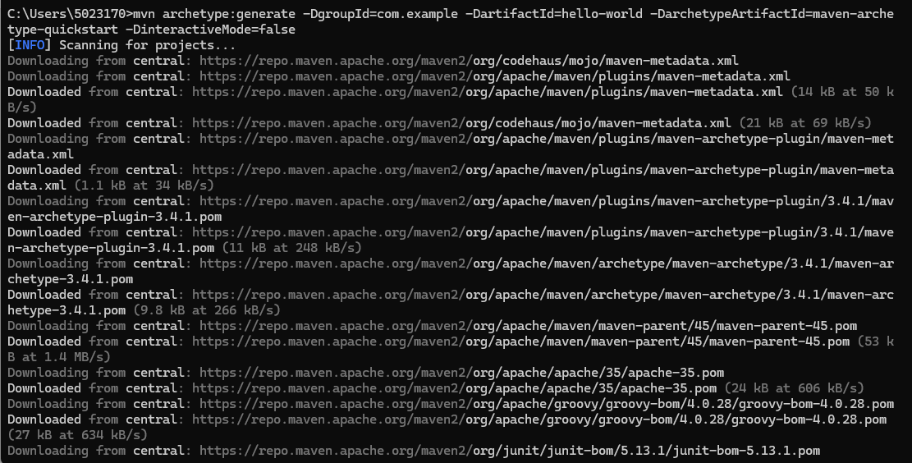
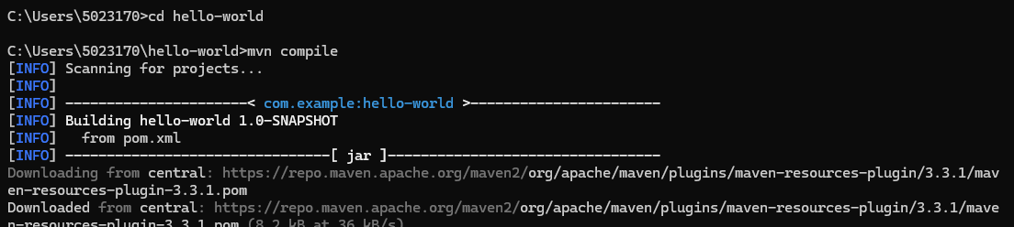
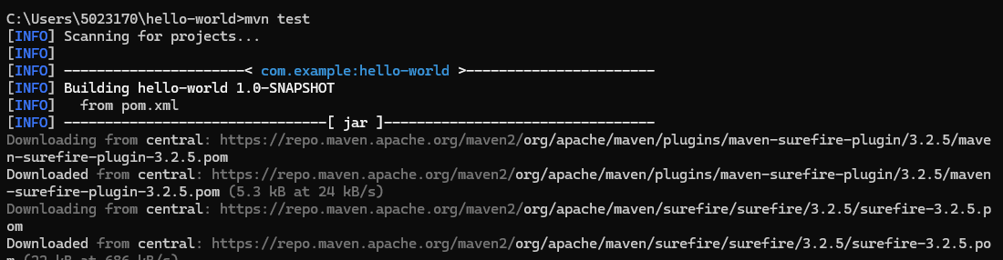
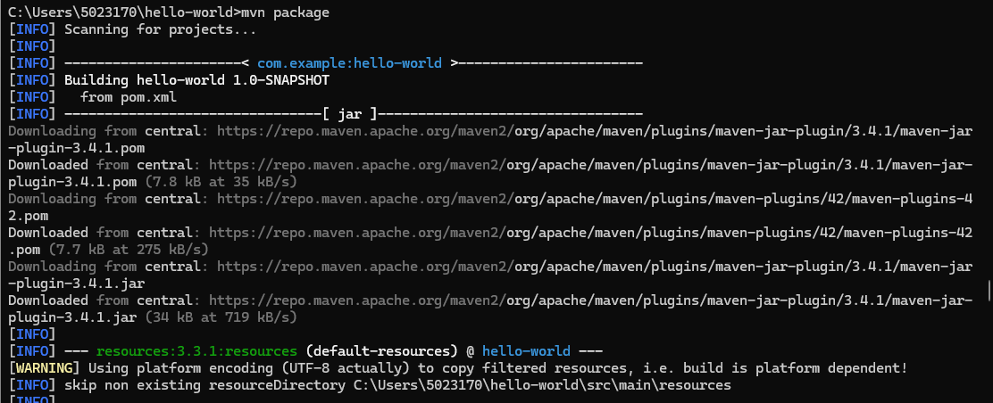
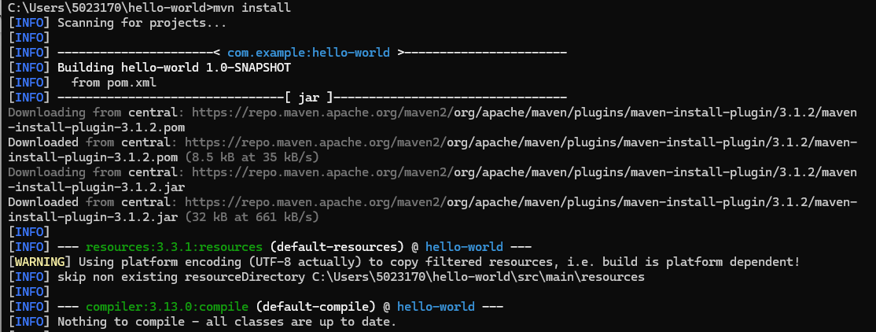
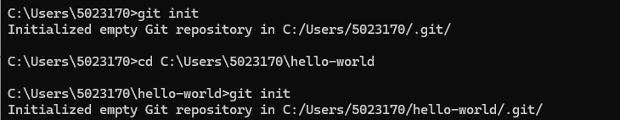
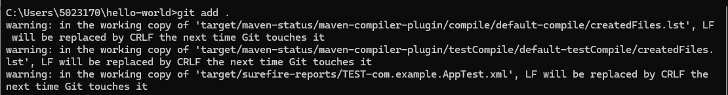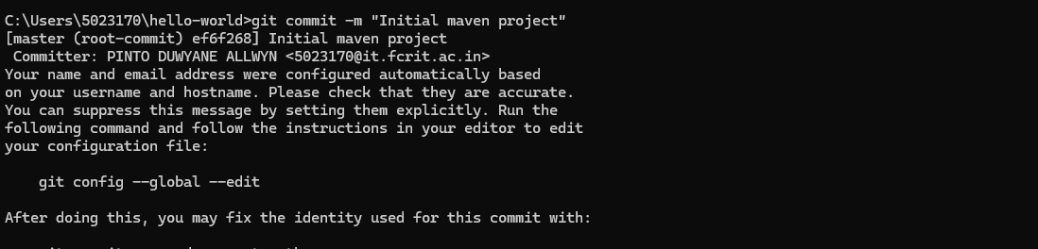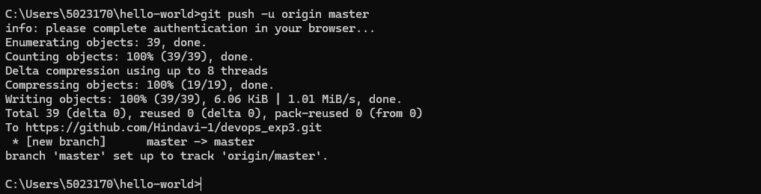
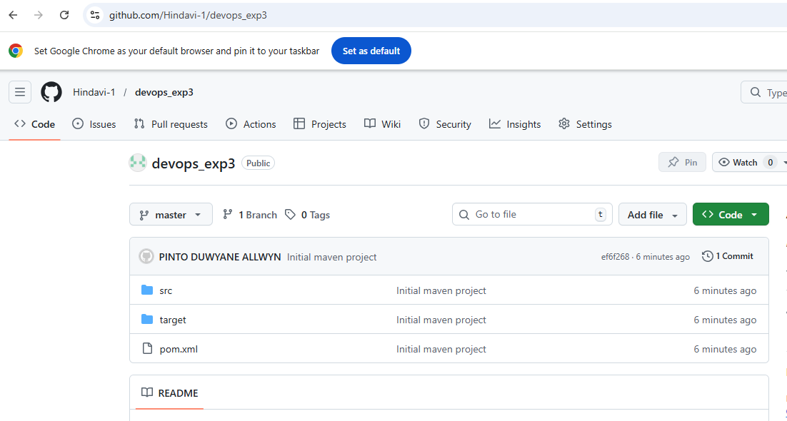
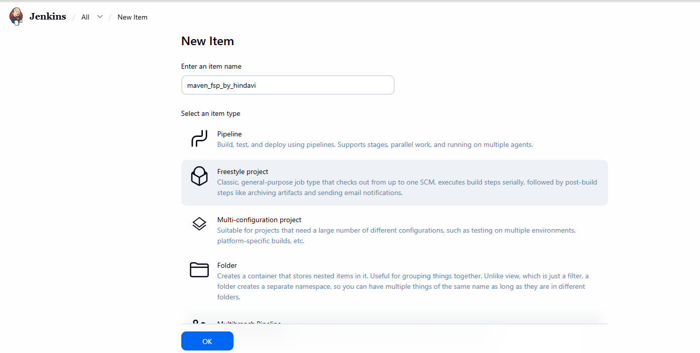
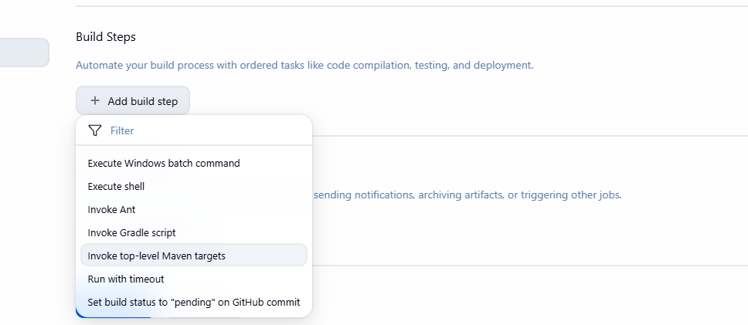
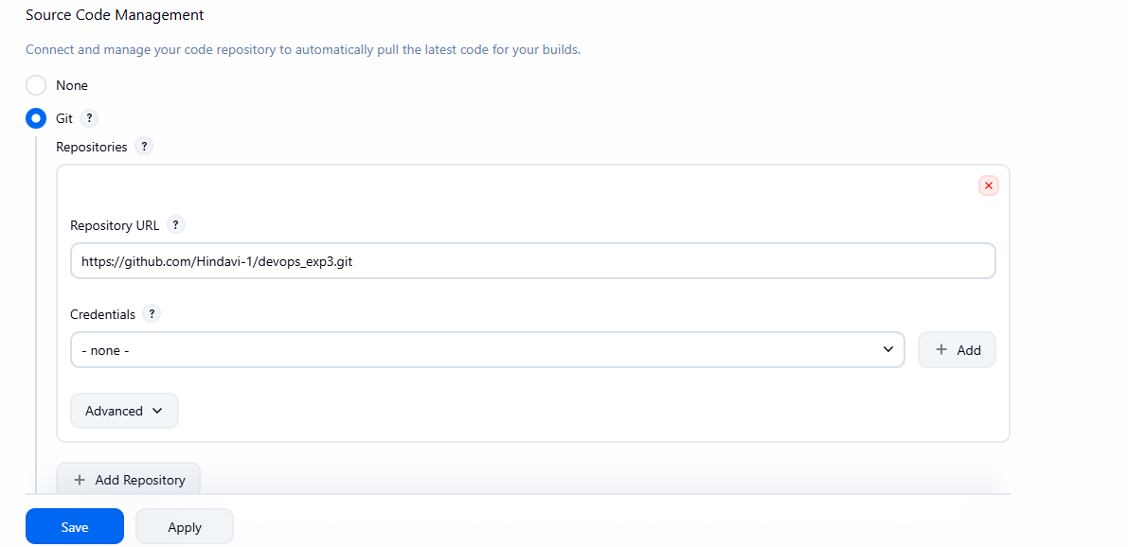
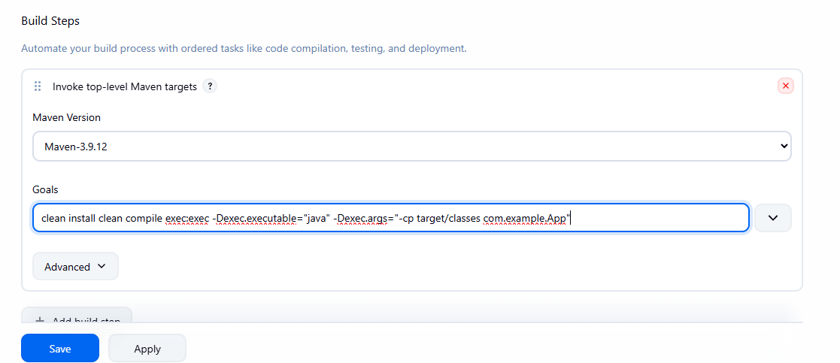
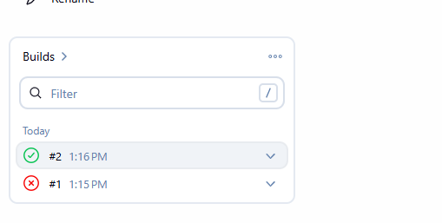
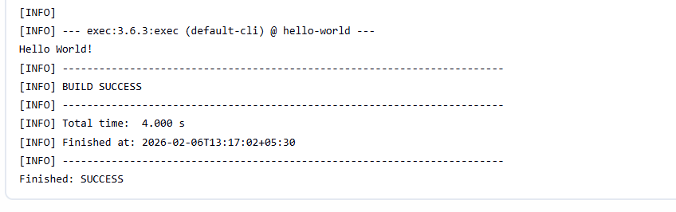
clean install
clean compile exec:exec -Dexec.executable="java" -Dexec.args="-cp target/classes com.example.App"

